# SCA Secondary School Council Meeting Minutes March 17,2021

1. Welcome/Call to Order - election of secretary (7:03)

Krista says Nate sounds like a secretary

2. Opening Prayer

Jon Elzinga - thanks we're still in school!

3. Additions to/ Approval of Agenda

Jeremy motion / Jeff second

4. Approval of Minutes

Krista motion / Angie approve.  Nate can't approve his own minutes.

5. Trustee Report – Trina Boymook

The provincial budget was tabled on February 25, 2021. It is being viewed by school boards as a good news budget considering the financial climate in a pandemic. Board Chairs and Superintendents met with the Minister following the tabling of the budget to receive a high-level overview of the Education budget

* The funding commitment to education is being maintained at $8.2B
* Boards will be held harmless from their enrolment declines as result of COVID-19. This is something that the Board had advocated for.
* Student transportation funding will remain at the same level. We are expected to receive some details coming out of the taskforce that will have transportation running more efficiently and effectively.
* 14 new capital projects were announced March 10. Extremely disappointed that Sherwood Heights did not make the list of supported projects.
* Increase support for modular program
* $40M will be shifted from Plant, Operation and Maintenance (POM) to Specialized Learning Supports. The minister is working on finalizing the finer details of this and once completed Boards will receive their funding letters. Specialized Learning Supports include
  + PUF – Boards have been advocating for additional supports in this area.
  + First National Metis and Inuit
  + English language Learners
  + Social Economic
  + Geographic
  + School Nutrition

Boards will have their funding letter by March 31 at the latest. The Board will be approving allocations to school at its April 22, 2021 Board meeting. So please plan on having a school budget discuss as a school council. The Board will also be setting student transportation fees and other administrative fees at this meeting.

The Board also approved the Three-Year Capital Plan. Number one request is a replacement school that combines Ecole Campbelltown and Sherwood Heights.

February 19, 2021 Trustee Seutter and I met with MLA Glubish to talk about our new vision for Sherwood Heights and how we plan on addressing access spaces at Salisbury Composite. It was a very productive 40-minute meeting.

The Board approved the support for a school council representative from a school to attend the upcoming Alberta School Councils Association Annual Conference and AGM. The Board will be supporting up to 15 registrations. Corrie will provide you with the information on how to access the support.

Aileen: is there anything we can do as a community to advocate for Sherwood Heights?  Trina agrees this is a community problem and express how we feel to MLAs and Minister of Education.  Hopeful community will rally around and express desire for resolution.

Krista says as a council we could make a choice as council to write a letter in solidarity for Sherwood Heights.

Krista moves we take a stand of solidarity and write a letter in support Sherwood Heights replacement.  Seconded by Devon.

Trina says Sherwood Heights council will be touched by that.

6. COSC Report – Devon Marshall    
  -We are hoping to return as normal as possible in   
September. We will need to be intentional with what we bring back because of both funding and AHS guidelines.   
 - $130 million covid mitigation. There will be a budget meeting in May   
  -Technology Fee- Conversations are starting and are ongoing. We are using more and more technology in our schools and the boards are struggling with this. Do we do BYOD or do a tech fee?   
-  Evergreen fund stopped to get money. $444,000 due to budget cutbacks.   
 - Covid update- Overall cases are going down. Only 4 new cases. (3 @ BF and 1 @SH. Only 1 is the new variant) There is no easing on restrictions but libraries are opening and hot lunch is happening in schools where there is enough man power.   
 - Quarter and final exams- Everyone will be writing exams   
  -Sports - in support of outside sports if AHS allows but not in our schools for spring

No questions

7. Admin Report (Jon Elzinga)

Quarter 3 is going very well! It has been great to not have any classes have to

quarantine for quite some time now. It is important that we don’t let our guard down

regarding COVID safety protocols. We need to continue to keep everyone safe.

2. Registration for next year is complete. We are projecting a student population around

615 students which is up about 25 students from last year.

3. Course selection in high school has begun this week. The courses that students select

help us to project the timetable needs for the upcoming year. Students can still make

changes after the timetable comes out, however, knowing how many students are

planning on taking certain subjects, allows us to have an accurate and balanced

timetable

4. Junior High Option Selections will begin on April 14. More details and information will be

coming regarding options selection, but this year, Junior High Option Selection will be

done through PowerSchool. Using PowerSchool will allow students and parents to still

choose their preferred junior high options, but will also allow our office to be much more

streamlined and efficient as we make the timetable. More instructions will be coming,

including a tutorial video on how to navigate the option selections. For now, make sure

that you know your PowerSchool parent portal account username and password as you

will need that information on April 14.

   1. Shelter Canada Update (Wes Merta)

   2. Fees (Denise Marshman)

   3. Parent Session - Dr. Alex Russell - April 21 @ 7:00 PM  (Matt Matheson)

           Krista gives thanks for thinking of parents and sharing with other schools.

           Trina very excited for this session.  Trina calling on Devon to get 200 parents out.

   4. BYOD Information Session (Wes Merta)

We're the only BYOD school in EIPS.  Kelly Stoski commented on short notice for Grade 9 this year that they didn't expect.  Jon sympathizes, not sure why the letter was delayed.  Loaners are also available.

 Devon wants to know what "resounding success" means.  Wes says class movement to computers is seamless compared to days of going to computer labs.

Krista wants measurable success, how would that be tracked?  What are the metrics?  Costs can be prohibitive for parents potentially.

Wes has survey information from parents related to satisfaction in program and can show that data.  Teachers also express support for the program.

Krista asked if an early communication strategy could be done so parents can prepare farther in advance for parents to prepare.  Mid-March is the current date of the letter, that information is shared with Grade 7/8 students as well as preparation.

Devon wondering if students encounter less connection with teacher having a screen in between them.  Wes says there are suggestions in place for screens to be closed during key lecture or discussion time.

Kelly asked why BYOD doesn't show up on the supply list.  Jon clarifies supply list are generic for all schools in the district, so it doesn't show up there.  Loaners are available if somebody doesn't have it.

Sandy asked about the school doing a large purchase order and discount and then having parents purchase from the school. That way all students can be streamlined on same type of device. Jon explained that the school does complete larger orders through EIPS for all of the school owned devices. Free loaner devices are available to any family that needs them.

8. SCA Society Report Business – Jeremy Teeuwsen & Jeff Schellenberg

Aileen clarified she needs to bring things back to the group to seek council input and signed on to the letter with Society to show leadership.

Jeremy covered the projects.  Krista asked if any other parents wanted to know about access control because she didn't know.  Mostly around keeping people from sneaking through other areas unknown. Doors to limit access between church and school.

Jeff discussed agreement proposal.

Krista has some specific questions -> Point 1: understand what it means of participation of SCA member (or do you mean director?)  Jeff says it should say director (likely treasurer).  Krista thinks it shouldn't be a requirement on SPAC member as well.  This looks like steps to accountability and transparency most parents want.  Still not a fan of this governance structure and would like to see an independent board.  Jeff agrees we are moving to a very unique hybrid model.  She like this proposal and sees it as the first step in a longer process.  Jeff says there will need to be some term on this as things like the mortgage ends and lease expires which fundamentally change the dynamics and new agreements will need to be sorted out.  There will be opportunities to amend and address issues as they come up.

Aileen asked what the group would look like.  Jeff says we need a smaller nimble group but will continue to engage school councils to get the parent input and concerns.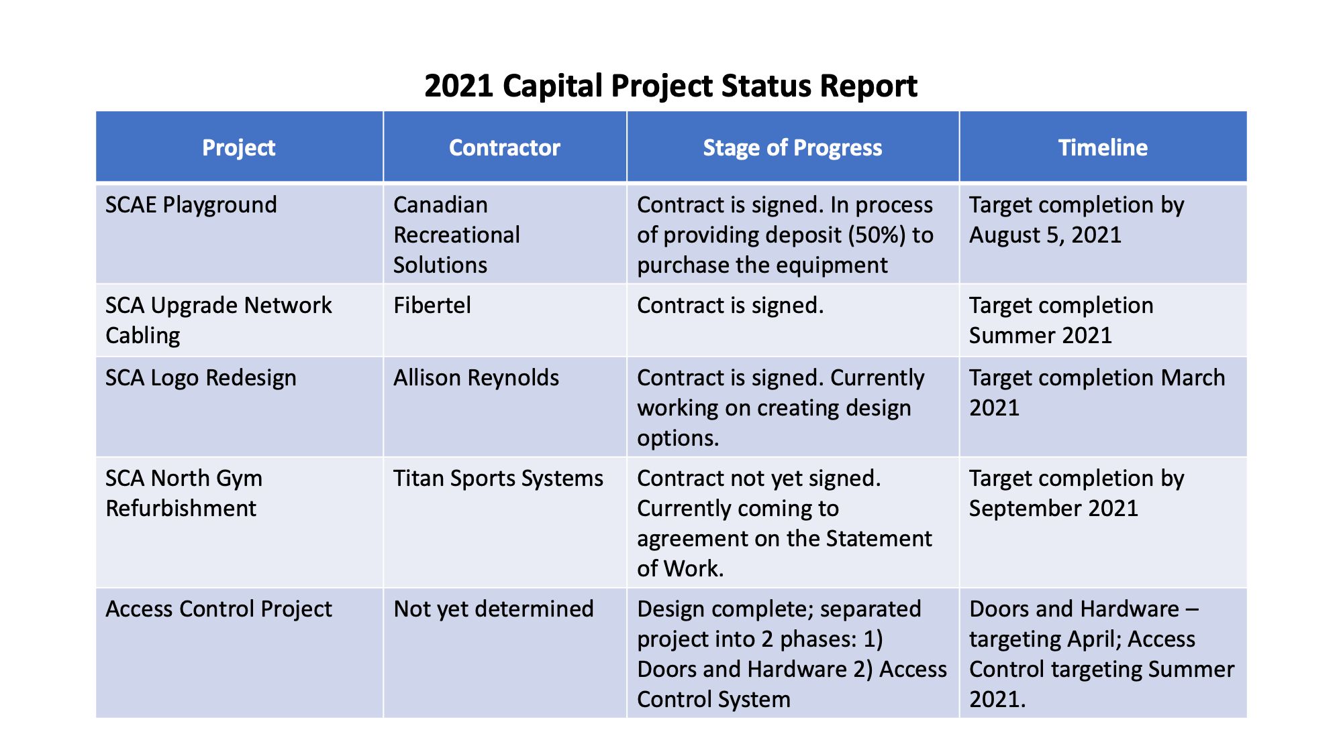

9. New Business

   1. After Grad Parent Committee Donation Letter (Alyssa Ottahal)

Safe grad for June 24th.  Guessing what the COVID restrictions may be.  We're looking to raise $8K, bottle drives may get us half way there.  Even looking for grocery cards to help with buying the food for the kids.

Aileen says we have roughly $800+ in our council account that we can use for a donation to the grad committee.  Any comments or objections?  No oppositions.  Devon makes motion to give $200, and Kelli L seconds.

   2. ASCA Resolutions - Aileen Bozic & Krista Scott

Krista reads too fast, Nate got the numbers down but not the titles.  Aileen/Krista you spoke mostly in this spot, so please expand as you wish.

ASCA ( Alberta School Council Association)- This is the group who advocates for the parents voice at the provincial level. These resolutions are brought forward by different school councils with in the province and one delegate from each council is able to vote in support or not to support for ASCA to advocate for each resolution.

11: Allocating Public Funds to Public Education: - Ran out of time to discuss.

9: Equal opportunity for equal access to all public schools.  Krista is not an expert on charter schools and there is a lengthy background to this whole issue. Trina asks why the charter school are at this association asking for more funding that they don’t qualify for. The word “appalling” was used multiple times. Krista outlines the process for those councils being part of the process and how these resolutions come forward to the members. Lengthy discussion on charter vs private. Trina can only give her opinion, choice is still up to the council.

1: Advancement of technology in all schools, including assisting those in remote areas with limited access.  Aileen will vote Yes on this unless there are objections.

Aileen: how do we seek parent feedback on all these resolutions? Krista suggested a survey or ask permission from council to vote your conscience. Council gives Aileen permission to vote on our behalf.

10. Closing Prayer and Adjournment (9:27)

11. Next Meeting Date – April 21, 2021 (at 6:30)

Attendees:

Alissa Ottahal

Angela Nieto

Nate Peters

Aileen Bozic

Angie Fehr

Christina Froehlich

Trevor Froehlich

Devon Marshall

Jacqueline Newgaard

Jeff Schellenberg

Jeremy Teeuwsen

Jon Elzinga

Kelli Littlefair

Kelly Stoski

Krista Scott

Matt Matheson

Matthias Cheung

Nick Moore

Pauline Gurnett

Sandy Rysavy

Trina Boymook

Wes Merta

Denise Marshman